1. Complete the Drawings found under the course MECH 211 - Class 6 {Drawings} - Coursework
   1. **Create the Wheel Mount Part Drawing (under the header Drawings)**
      1. **Use parts/assemblies from the coursework from prior Classes**
      2. **Watch all relevant videos (From “Drawings Overview…” through “Section View” videos)**
      3. **Complete the drawing**
      4. **Save the drawings in their final configuration for use in future classes. Use the Pack and Go Function to save your drawing along with the assembly and the child parts.**
         1. **Name the .zip file LASTNAME_FIRSTNAME_WHEEL_MOUNT_DRAWING.zip**
         2. **Upload the full zip file to Brightspace to receive credit**
      5. **Follow all steps, it will help familiarize you with all aspects of drawing design**
   2. **Create the Caster Wheel Assembly Drawing (under the header Drawings)**
      1. **Use parts/assemblies from the coursework from prior Classes**
      2. **Watch all relevant videos (From “Assembly Drawing” through “Balloons” videos)**
      3. **Complete the drawing**
      4. **Save the drawings in their final configuration for use in future classes. Use the Pack and Go Function to save your drawing along with the assembly and the child parts.**
         1. **Name the .zip file LASTNAME_FIRSTNAME_CASTER_WHEEL_ASSY_DRAWING.zip**
         2. **Upload the full zip file to Brightspace to receive credit**
      5. **Follow all steps, it will help familiarize you with all aspects of drawing design**
   3. **Create the Clevis Part Drawing (Exercise + Video: Part Drawing – Clevis)**
      1. **Follow along the “Exercise + Video: Part Drawing – Clevis”**
      2. **Download parts from Brightspace**
      3. **Complete the drawing**
      4. **Either way, Save the drawings in their final configuration for use in future classes. Use the Pack and Go Function to save your drawing along with the assembly and the child parts.**
         1. **Name the .zip file LASTNAME_FIRSTNAME_CLEVIS_DRAWING.zip**
         2. **Upload the full zip file to Brightspace to receive credit**
      5. **Follow all steps, it will help familiarize you with all aspects of drawing design**
   4. **Create the Holder Part Drawing (Exercise + Video: Part Drawing – Holder)**
      1. **Follow along the “Exercise + Video: Part Drawing – Holder”**
      2. **Download parts from Brightspace**
      3. **Complete the drawing**
      4. **Either way, Save the drawings in their final configuration for use in future classes. Use the Pack and Go Function to save your drawing along with the assembly and the child parts.**
         1. **Name the .zip file LASTNAME_FIRSTNAME_HOLDER_DRAWING.zip**
         2. **Upload the full zip file to Brightspace to receive credit**
      5. **Follow all steps, it will help familiarize you with all aspects of drawing design**
   5. **Create the Brace Assembly Drawing (Exercise + Video: Assembly Drawing – Brace)**
      1. **Follow along the “Exercise + Video: Assembly Drawing – Brace”**
      2. **Download parts from Brightspace**
      3. **Complete the drawing**
      4. **Either way, Save the drawings in their final configuration for use in future classes. Use the Pack and Go Function to save your drawing along with the assembly and the child parts.**
         1. **Name the .zip file LASTNAME_FIRSTNAME_BRACE_ASSY_DRAWING.zip**
         2. **Upload the full zip file to Brightspace to receive credit**
      5. **Follow all steps, it will help familiarize you with all aspects of drawing design**

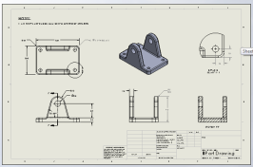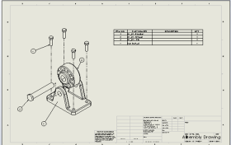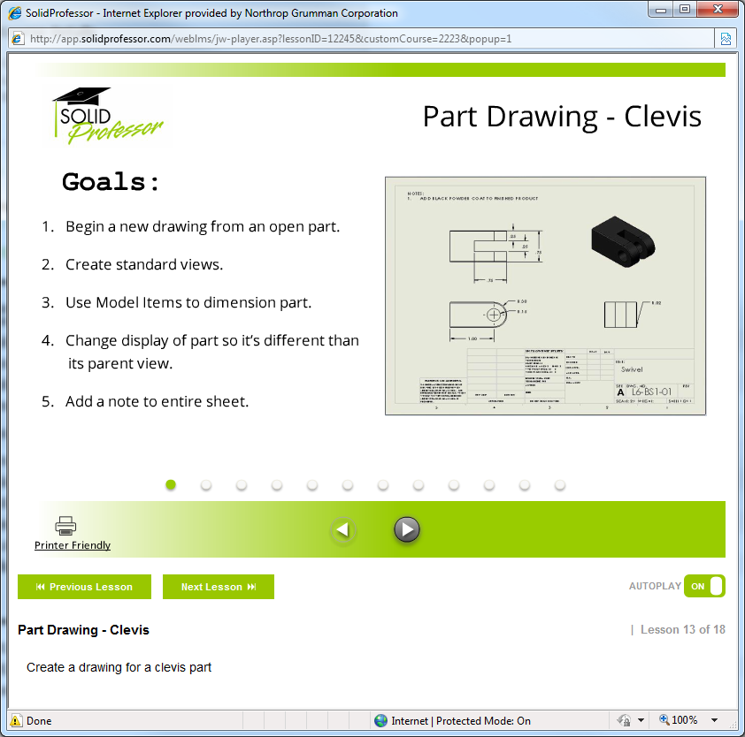 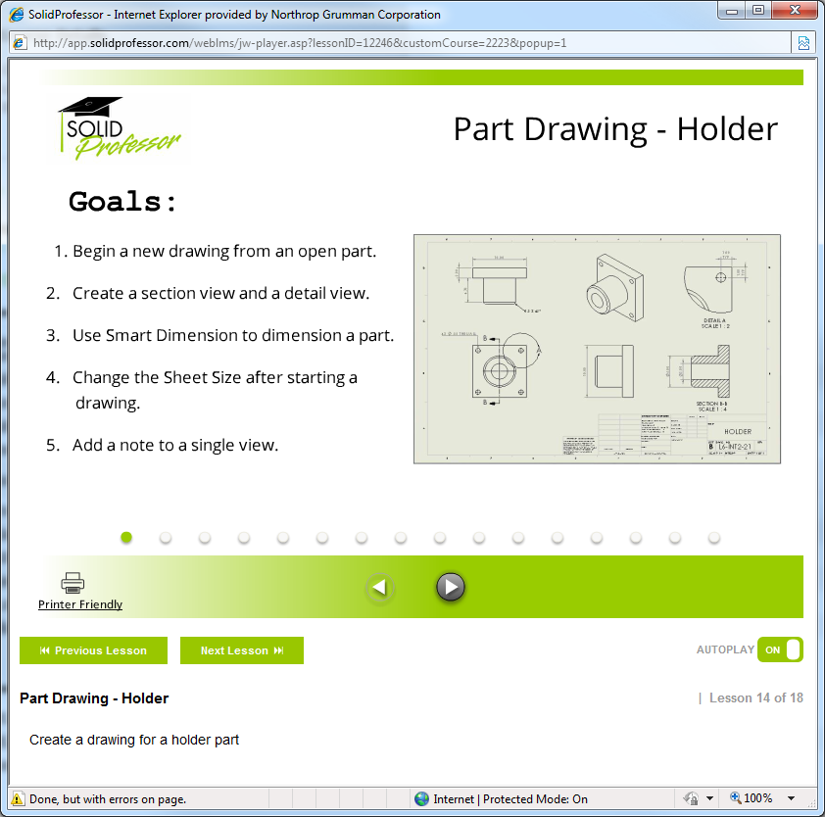 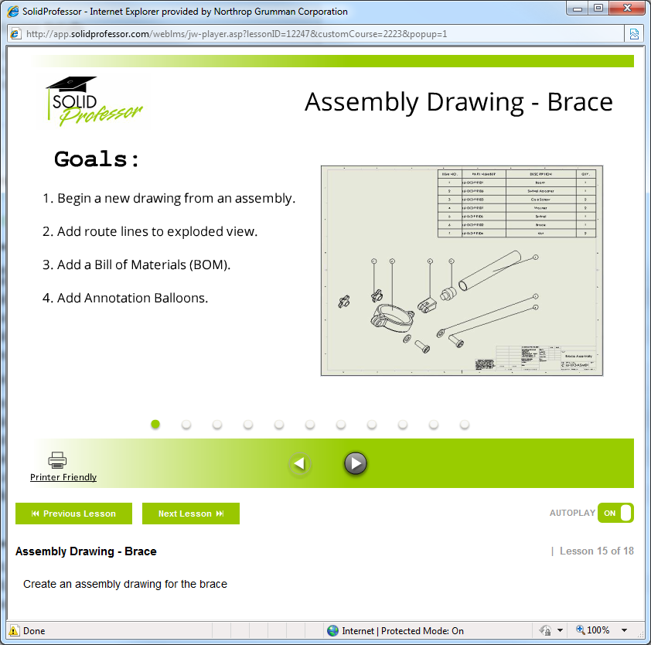

Wheel Mount Drawing |Caster Wheel Assy Drawing| Clevis Part Drawing | Holder Part Drawing | Brace Assy Drawing